NAME: KAVITAPU SWARNA VARSHINI
REG.NO: 192324081
DATE: 14-07-2026

Write a python program for Travelling Salesman Problem (TSP)
AIM: To write a Python program to solve the Travelling Salesman Problem (TSP) by finding the minimum-cost tour that visits each city exactly once and returns to the starting city.
ALGORITHM:
- Represent the distances between cities using a distance matrix.
- Fix one city as the starting point.
- Generate all possible routes (permutations) of the remaining cities.
- Calculate the total cost of each route, including the return to the starting city.
- Display the route with the minimum travel cost.
CODE:
from itertools import permutations

graph = [
[0, 10, 15, 20],
[10, 0, 35, 25],
[15, 35, 0, 30],
[20, 25, 30, 0]
]

n = len(graph)
min_cost = float('inf')
best_path = ()

for path in permutations(range(1, n)):
cost = 0
k = 0
for i in path:
cost += graph[k][i]
k = i
cost += graph[k][0]

if cost < min_cost:
min_cost = cost
best_path = (0,) + path + (0,)

print("Best Path:", best_path)
print("Minimum Cost:", min_cost)
OUTPUT:
Best Path: (0, 1, 3, 2, 0)
Minimum Cost: 80
IMAGE:
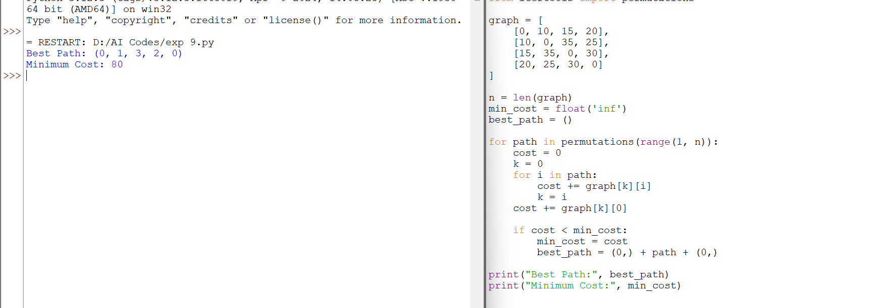

RESULT:
The Python program successfully solved the Travelling Salesman Problem (TSP) by finding the route with the minimum travel cost. The optimal tour obtained has a minimum cost of 80.

